Lobster launches with unlimited calls and texts in Spain, to the UK and other countries.
- Lobster launches competitive tailor-made tariff plans for British expatriates, and other English speakers, who reside in Spain, with unlimited calls and texts and great data deals, starting from just 12€ per month VAT included
- Simple and easy to become a Lobster customer. Starting from 18th December, the service will be available online at lobster.es or by calling free to its Customer Contact Centre on 1661
- The customer has complete control with no commitments or hidden surprises
- Lobster DNA is "English, easy and effortless" so that the customer will be able to enjoy a service and experience "like home"
- The Customer Contact Centre, exclusive to Lobster, has agents that communicate with customers in native English

Madrid 18th December, 2018. Lobster, the only mobile operator in Spain to offer a service completely in English, announces competitive tailor-made tariff plans for British expatriates, and other English speakers, who reside in Spain. It is estimated that there are over 1.5 million English speakers residing in Spain and Lobster wants to be the benchmark for this market, and grow rapidly in the coming years.
Starting from 18th December, customers will be able to choose from 3 simple and competitive tariff plans with unlimited calls and texts and great data deals, starting from just 12€ per month VAT included:
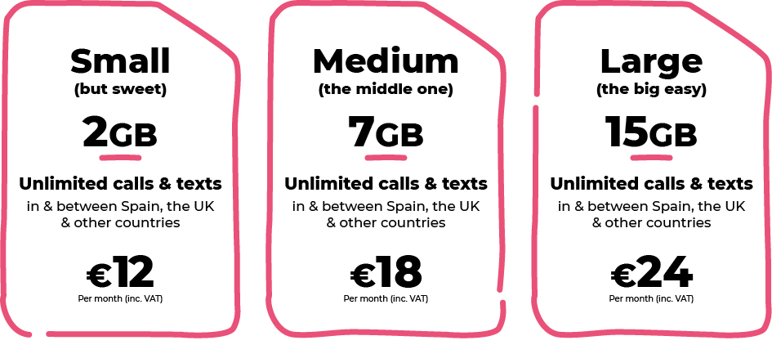
All our tariff plans include unlimited calls and texts in Spain, to the UK, Denmark, Germany, Gibraltar, Ireland, Netherlands, Norway, Portugal, Sweden and the USA.

Also, the tariff plans include "Roam Like At Home" so that customers can enjoy the same services while at home in any one of the 31 countries in the European Economic Area, at no additional cost. Customers can also pay to make international calls to those countries around the world that are not already included in Lobster's unlimited tariff plans, and can also roam abroad in 60 countries outside the European Economic Area.
The customer will be able to easily pay for the services each month using a credit or debit card via a secure payment method, like other operators already do successfully in the UK. There are no tie-ins or commitments. Customers will be able to cancel their monthly subscription whenever they wish and have complete control over their monthly spend. Additionally, customers will be able to "park" their number and service for up to 12 months, whilst they return to the UK or elsewhere so it can be available for use on return to Spain.
It is very easy and simple to become a Lobster customer, just identify yourself and provide a payment method for paying month by month, and you’re good to go.
Initially, signing up for the service can be done online via its website lobster.es or by calling free to its Customer Contact Centre on 1661. In early 2019 it will also be possible to sign up via an extensive network of physical specialised retail outlets as well as other points of sales.
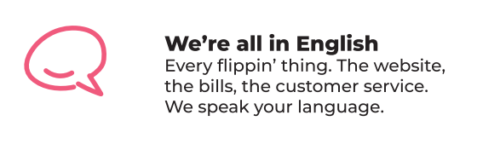
The Customer Contact Centre, exclusive to Lobster, has agents that communicate with customers in native English. It will provide a high quality service for the entire English speaking community, as well as handling calls and providing documentation in Spanish for those customers who prefer.
The Lobster brand was created to establish an emotional bond with British values and service. The DNA of the Company is "English, easy and effortless" together with a personality that is authentic and straightforward. Its offering is based on simplicity and understanding the customer so that they will be able to enjoy a service and experience "like home".
"Today is a great day. With Lobster we will meet the needs of expatriate customers who are currently underserved when it comes to mobile services in Spain. We have built a mobile service similar to what they would expect in their home countries. It is our aim to make them feel "like home" when becoming a Lobster customer. We’re excited to announce our competitive and easy to understand tariff plans and a service which, of course, is all in English," said Gabriel Miguez, Managing Director of the company.
Lobster uses Telefónica coverage to provide the best quality national service, with the rest of the technological Infrastructure supplied by Gibtelecom.
ABOUT LOBSTER
Lobster is the first Spanish mobile operator for British expatriates, and other English speakers, who reside in Spain. Lobster is the registered brand of Zinnia Telecomunicaciones, a Spanish company and part of the Gibtelecom Group. Zinnia Telecomunicaciones has the financial and business support of Gibtelecom, the main operator in Gibraltar providing fixed lines, mobile and TV, as well as business enterprise services. The Group also has submarine cable and European fibre network investments, and runs data centres through its subsidiary, Rockolo Limited.
Press Contact
Telephone 711 000 125, Email press@lobster.es
More information at lobster.es or find us on Twitter, Facebook, Instagram or YouTube.

