Lobster continues to grow with thousands of happy customers and is now available in over 400 retail stores in Spain.

- Lobster is the only mobile operator in Spain to offer a service completely in English
- Lobster's competitive tariff plans all come with unlimited calls and texts in Spain, to the UK and other countries, and great data deals, and start from just 12€ per month VAT included. They are tailor-made for British expatriates, and other English speakers, who reside in Spain
- In just 6 months after having launched, Lobster has expanded its physical sales network so that Lobster is now available in over 400 specialised retail stores as well as other points of sales, to meet the increasing customer demand for its services
- Lobster has thousands of happy customers and is growing rapidly with its winning formula of all-in-English and providing an "English, easy and effortless" service with a customer experience "like at home"
- Lobster continues with its "First month free" promotion

Madrid 26th June, 2019. Lobster, the only mobile operator in Spain to offer a service completely in English, announces that in just 6 months after having launched, it has expanded its physical sales network so that Lobster is now available in over 400 specialised retail stores as well as other points of sales.
Lobster targets British expatriates, and other English speakers, who reside in Spain, located mainly on the Mediterranean coast, the Balearic and Canary Islands. It is estimated that there are over 1.5 million English speakers residing in Spain. This rapid sales channel expansion demonstrates that Lobster has been very well received by the expatriate community in Spain. Lobster is fast becoming the benchmark for this market with increasing customer demand for its services.
The Lobster brand was created to establish an emotional bond with British values and service. The DNA of the Company is "English, easy and effortless" together with a personality that is authentic and straightforward. The Lobster offering is based on simplicity and understanding customers enjoy a service and experience "like at home". This together with a service completely in English and competitive tariff plans tailor-made for expatriates has provided a winning formula that has appealed to thousands of happy customers and growing rapidly.
"We are very excited with the success and the exceptional customer growth in our first 6 months and we will continue to expand our sales channels to meet this demand. It clearly shows that we have got things right and most importantly that our customers are happy with our service. We have some great customer testimonials on our Facebook page," said Gabriel Miguez, Managing Director of the company.
Customers can choose from 3 simple and competitive tariff plans which all come with unlimited calls and texts in Spain, to the UK and other countries, and great data deals, and start from just 12€ per month VAT included. They are tailor-made for British expatriates, and other English speakers, who reside in Spain.
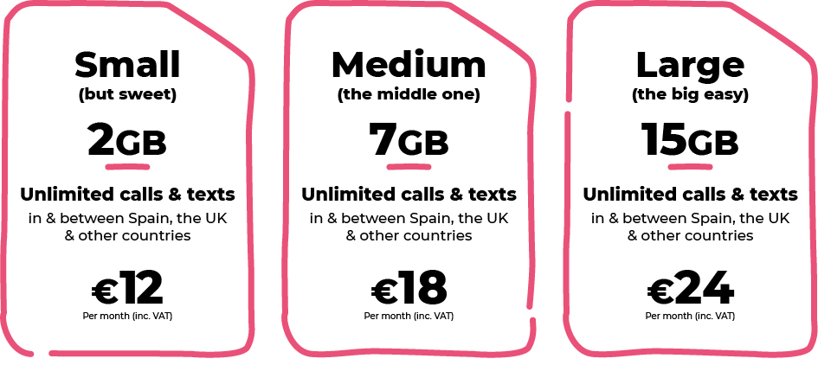
In addition to unlimited calls and texts in Spain and to the UK, all our tariff plans also include unlimited calls and texts to Denmark, Germany, Gibraltar, Ireland, Netherlands, Norway, Portugal, Sweden and the USA.

Also, the tariff plans include "Roam Like At Home" so that customers can enjoy the same services while at home in any country in the European Economic Area, at no additional cost.
Lobster continues with its "First month free" promotion where the first month's plan payment is free for new customers so that they can try the service. With Lobster there are no commitments, lock-ins or hidden surprises. Lobster wants it customers to stay because they're happy with the service.
It is very easy to become a Lobster customer, just provide identification, your credit or debit card payment details through a totally secure process for paying month by month, and you’re good to go. It doesn't have to be a Spanish credit or debit card. You can cancel at any time.
Signing up for the service can be done through any one of the over 400 retail stores. Customers can easily find the closest store to them using the store finder our website lobster.es. If customers prefer they can also sign up online or by calling our Customer Contact Centre for free on 1661 where all the agents are native English speakers.
ABOUT LOBSTER
Lobster is the only mobile operator in Spain to offer a service completely in English for British expatriates, and other English speakers, who reside in Spain. Lobster is the registered brand of Zinnia Telecomunicaciones, a Spanish company and part of the Gibtelecom Group. Zinnia Telecomunicaciones has the financial and business support of Gibtelecom, the main operator in Gibraltar providing fixed lines, mobile and TV, as well as business enterprise services. The Group also has submarine cable and European fibre network investments, and runs data centres through its subsidiary, Rockolo Limited.
Press Contact
Telephone 711 000 125, Email press@lobster.es
More information at lobster.es or find us on Twitter, Facebook, Instagram or YouTube.

