Lobster increases data by up to double across all its tariff plans, for everyone, with no changes in price.

- From today Lobster customers can now surf the internet more and for longer, with no changes in price!
- Lobster has increased data by up to double across all its tariff plans. The Small Plan now has 4GB per month, the Medium Plan 10GB, and the Large Plan 25GB.
- All Lobster tariff plans continue to include unlimited calls and texts in Spain, to the UK and other countries.
- Everyone gets the increase in data, both new customers and current customers. Lobster does not treat new customers better than current ones!
- Lobster's tariff plans are tailor-made for British expatriates, and other English speakers, who reside in Spain, and start from just 12€ per month VAT included.
- Lobster is the only mobile operator in Spain to offer a service completely in English.
- Lobster extends its "First month free" promotion for a limited time.

Madrid 5th November, 2019. Lobster, the only mobile operator in Spain to offer a service completely in English, announces from today that all its tariff plans have just got even better, with no changes in price.
Lobster has increased data permanently by up to double across all its tariff plans, so Lobster customers can now surf the internet more and for longer! All tariff plans continue to include unlimited calls and texts in Spain, to the UK and other countries, and start from just 12€ per month VAT included.
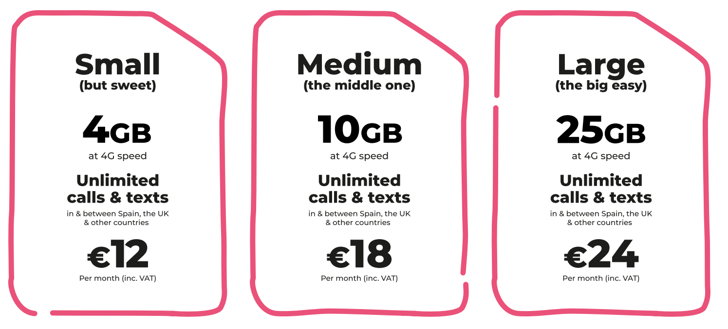
Everyone gets the increase in data, both new customers and current customers. Lobster does not treat new customers better than current ones! All current Lobster customers will get the data increase automatically, without having to do anything.
In addition to unlimited calls and texts in Spain and to the UK, all our tariff plans also include unlimited calls and texts to Denmark, Germany, Gibraltar, Ireland, Netherlands, Norway, Portugal, Sweden and the USA.

Also, the tariff plans include "Roam Like At Home" so that customers can enjoy the same services while at home in any country in the European Economic Area, at no additional cost.
Customers can keep their existing Spanish number if they already have one or we can give them a brand new one.
The Lobster brand was created to establish an emotional bond with British values and service. The DNA of the Company is "English, easy and effortless" together with a personality that is authentic and straightforward. The Lobster offering is based on simplicity and understanding customers enjoy a service and experience "like at home". This together with a service completely in English and tariff plans tailor-made for expatriates has provided a winning formula that has appealed to over 10,000 happy Lobster customers in just 9 months after launching and growing rapidly.
"Our customers asked for more data with the same great tariff plans with unlimited calls and texts at competitive prices. We are always listening to our customers and have acted increasing data for both new and current Lobster customers with no changes in price. It is important to us that our customers have the highest levels of satisfaction in the market," said Tony Watts, Marketing Director of the company.
Lobster extends its "First month free" promotion for a limited time where the first month's plan payment is free for new customers so that they can try the service. With Lobster there are no commitments, lock-ins or hidden surprises. Lobster wants it customers to stay because they're happy with the service.
It is very easy to become a Lobster customer, just provide identification, your credit or debit card payment details through a totally secure process for paying month by month, and you’re good to go. It doesn't have to be a Spanish credit or debit card. You can cancel at any time.
Signing up for the service can be done through any one of the over 600 retail stores. Customers can easily find the closest store to them using the store finder our website lobster.es. If customers prefer they can also sign up online or by calling our Customer Contact Centre for free on 1661 where all the agents are native English speakers.
ABOUT LOBSTER
Lobster is the only mobile operator in Spain to offer a service completely in English for British expatriates, and other English speakers, who reside in Spain. Lobster is the registered brand of Zinnia Telecomunicaciones, a Spanish company and part of the Gibtelecom Group. Zinnia Telecomunicaciones has the financial and business support of Gibtelecom, the main operator in Gibraltar providing fixed lines, mobile and TV, as well as business enterprise services. The Group has submarine cable and European fibre network investments, and runs data centres through its subsidiary, Rockolo Limited.
Press Contact
Telephone 711 000 125, Email press@lobster.es
More information at lobster.es or find us on Twitter, Facebook, Instagram or YouTube.

