Lobster celebrates its second anniversary of keeping people connected!

- Lobster, the only mobile network in Spain to offer a service completely in English, celebrates two years since launching service
- Brexit is just around the corner and there is a lot of uncertainty for British expatriates... But one thing for certain is that Lobster customers will continue to enjoy a great mobile service with no changes
- With Lobster you can be in Spain for as long as you like and use your tariff plan as much as you like, and never have to worry about any surprise mobile roaming charges
- This year has been challenging for everyone. Keeping connected with family, loved ones, and friends whether in Spain or back home, has been especially important for all of us
- Lobster's competitive tariff plans are tailor-made for British expatriates, and other English speakers, who reside in Spain
- Starting from just 12€ per month VAT included, all Lobster tariff plans come with unlimited calls and texts in Spain, to the UK and other countries, and great data deals

Madrid 18th December, 2020. Lobster, the only mobile network in Spain to offer a service completely in English, celebrates its second anniversary today! During its first two years Lobster has grown rapidly with its winning formula of all-in-English and providing a customer experience "like at home". Lobster is the benchmark mobile network for British expatriates, and other English speakers, who reside in Spain.
With Brexit just around the corner British expatriates residing in Spain are facing a lot of uncertainty going forward. At Lobster, no matter what happens with Brexit our tariff plans and our service will not be affected in any way. Lobster customers will continue to enjoy a great mobile service with no changes.
At Lobster we are closely connected to the British expatriate community and know that there is a lot of concern about surprise mobile roaming charges with UK SIMs when in Spain. With Lobster you can be in Spain for as long as you like and use your tariff plan as much as you like, and never have to worry about any surprise mobile roaming charges.
"This year has been very challenging for everyone and keeping in touch with family, loved ones, and friends, whether in Spain or back home, has never been more important. During these last 12 months we have seen an incredible demand for our services, and to keep people connected. It is important to us that our customers have the highest levels of satisfaction in the market. We look forward to celebrating many more anniversaries!" said Tony Watts, Marketing Director of the company.

Customers can choose from 3 simple and competitive tariff plans which all come with unlimited calls and texts in Spain, to the UK and other countries, and great data deals, and start from just 12€ per month VAT included. They are tailor-made for British expatriates, and other English speakers, who reside in Spain.
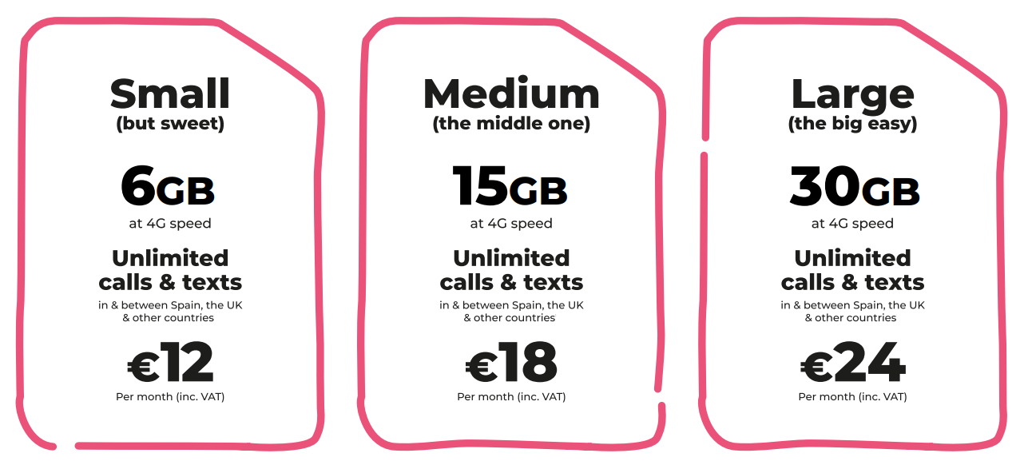
In addition to unlimited calls and texts in Spain and to the UK, all our tariff plans also include unlimited calls and texts to Denmark, Germany, Gibraltar, Ireland, Netherlands, Norway, Portugal, Sweden and the USA.

Also, the tariff plans include "Roam Like At Home" so that customers can enjoy the same services while at home in any country in the European Economic Area, at no additional cost.
With Lobster there are no commitments, lock-ins or hidden surprises. Lobster wants its customers to stay because they're happy with the service.
It is very easy to become a Lobster customer, just provide identification, your credit or debit card payment details through a totally secure process for paying month by month, and you’re good to go. It doesn't have to be a Spanish credit or debit card. You can cancel at any time.
Signing up for the service can be done online on our website lobster.es or by calling our Customer Contact Centre for free on 1661 where all the agents are native English speakers. If customers prefer, they can also sign up through any one of over 600 retail stores, the closest of which can easily be found using the store finder on our website lobster.es.

ABOUT LOBSTER
Lobster is the only mobile operator in Spain to offer a service completely in English for British expatriates, and other English speakers, who reside in Spain. Lobster is the registered brand of Zinnia Telecomunicaciones, a Spanish company and part of the Gibtelecom Group. Zinnia Telecomunicaciones has the financial and business support of Gibtelecom, the main operator in Gibraltar providing fixed lines, mobile and TV, as well as business enterprise services. The Group has submarine cable and European fibre network investments, and runs data centres through its subsidiary, Rockolo Limited.
Press Contact
Telephone 711 000 125, Email press@lobster.es
More information at lobster.es or find us on Twitter, Facebook, Instagram or YouTube.

