Lobster, the mobile network made for English speakers in Spain, celebrates its third anniversary!

- Lobster, the only mobile network in Spain to offer a service completely in English, celebrates three years since launching service
- There has never been a better time to join Lobster and get a local SIM in Spain!
- After Brexit many UK mobile networks are introducing roaming charges in Spain. With Lobster you can be in Spain for as long as you like, and use your tariff plan as much as you like, and never have to worry about any roaming charges or bill shocks
- Starting from just 12€ VAT included, all Lobster tariff plans come with unlimited calls and texts in Spain, to the UK and other countries, and big data deals
- With Lobster you can also roam in the UK, or any country in the European Economic Area, at no additional cost
- What's more, all Lobster customers get a whopping 50% more data until the end of March 2022!
- And finally, this time next year you'll be a millionaire... Lobster customers can now earn money! For every friend you bring to Lobster we’ll give you 5€, and your friends get 5€ off their first plan payment too. So, everyone’s a winner!

Madrid 18th December, 2021. Lobster, the only mobile network in Spain to offer a service completely in English, celebrates its third anniversary today! After just three short years Lobster has established itself as the benchmark mobile network for British expatriates, and other English speakers, who reside in Spain.
Brexit brought with it a lot of uncertainty for British living in Spain, but one thing for certain is that Lobster customers continue to enjoy a great mobile service in Spain with no changes. The same cannot be said for British in Spain using their UK SIMs. One of the changes that we are now seeing after Brexit is that many UK mobile networks are introducing mobile charges when roaming in Spain. These mobile roaming charges can be very expensive and lead to bill shocks.
Lobster has always recommended getting a local SIM in Spain for British expatriates, and other English speakers. With Lobster you can be in Spain for as long as you like and use your tariff plan as much as you like, and never have to worry about any mobile roaming charges or bill shocks.
At Lobster we are great believers in that our customers are the best ambassadors of the great service we provide. Lobster customers can now earn money for recommending Lobster to friends! For every friend you bring to Lobster we’ll give you 5€, and your friends get 5€ off their first plan payment too. So, everyone’s a winner! So maybe, this time next year you'll be a millionaire!
Customers can choose from 3 simple and competitive tariff plans which all come with unlimited calls and texts in Spain, to the UK and other countries, and big data deals, and start from just 12€ VAT included. They are tailor-made for British expatriates, and other English speakers, who reside in Spain.
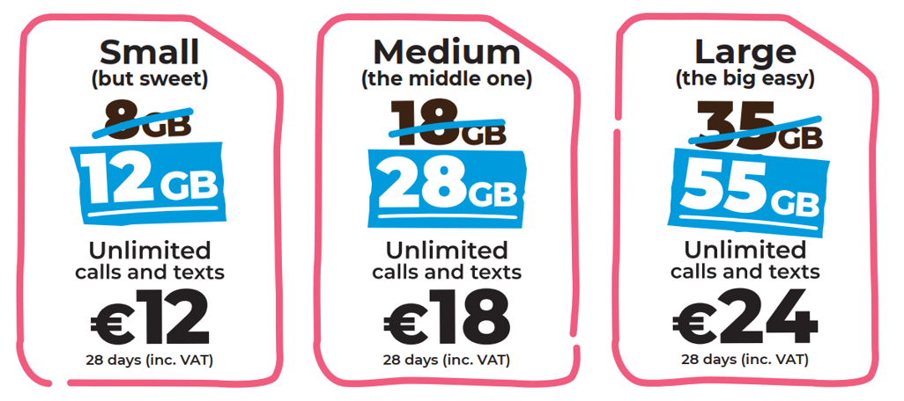
In addition to unlimited calls and texts in Spain and to the UK, all our tariff plans also include unlimited calls and texts to Denmark, Germany, Gibraltar, Ireland, Netherlands, Norway, Portugal, Sweden and the USA.

With Lobster you can also roam in the UK, or any country in the European Economic Area, at no additional cost. What's more, all Lobster customers get a whopping 50% more data until the end of March 2022. Lobster customers can now surf the internet more and for longer!
With Lobster there are no commitments, lock-ins or hidden surprises. Lobster wants its customers to stay because they're happy with the service.
It is very easy to become a Lobster customer, just provide identification, your credit or debit card payment details through a totally secure process, and you’re good to go. It doesn't have to be a Spanish credit or debit card. You can cancel at any time.
Signing up for the service can be done online on our website lobster.es or by calling our Customer Contact Centre for free on 1661 where all the agents are native English speakers. If customers prefer, they can also sign up through any one of over 600 retail stores, the closest of which can easily be found using the store finder on our website lobster.es.

ABOUT LOBSTER
Lobster is the only mobile operator in Spain to offer a service completely in English for British expatriates, and other English speakers, who reside in Spain. Lobster is the registered brand of Zinnia Telecomunicaciones, a Spanish company and part of the Gibtelecom Group. Zinnia Telecomunicaciones has the financial and business support of Gibtelecom, the main operator in Gibraltar providing fixed lines, mobile and TV, as well as business enterprise services. The Group has submarine cable and European fibre network investments, and runs data centres through its subsidiary, Rockolo Limited.
Press Contact
Telephone 711 000 125, Email press@lobster.es
More information at lobster.es or find us on Twitter, Facebook, Instagram or YouTube.

