Everyone's a winner with Lobster! Double or more data for everyone, for the same price!

- From today Lobster customers can now surf the internet more and for longer, for the same price!
- Lobster has increased data by double or more in all its tariff plans. The Small Plan now has 18GB, the Medium Plan 40GB, and the Large Plan 70GB.
- All Lobster tariff plans continue to include unlimited calls and texts in Spain, to the UK and other countries.
- Everyone gets the increase in data, all new customers and current customers. Lobster does not treat new customers better than current ones!
- Lobster's tariff plans are tailor-made for British expatriates, and other English speakers, who reside in Spain, and start from just 12€ VAT included.
- Lobster is the only mobile operator in Spain to offer a service completely in English.

Madrid 15th February, 20212 Lobster, the only mobile operator in Spain to offer a service completely in English, announces from today that all its tariff plans have just got even better, for the same price.
Lobster has increased data by double or more permanently in all its tariff plans, so Lobster customers can now surf the internet more and for longer! All tariff plans continue to include unlimited calls and texts in Spain, to the UK and other countries, and start from just 12€ VAT included.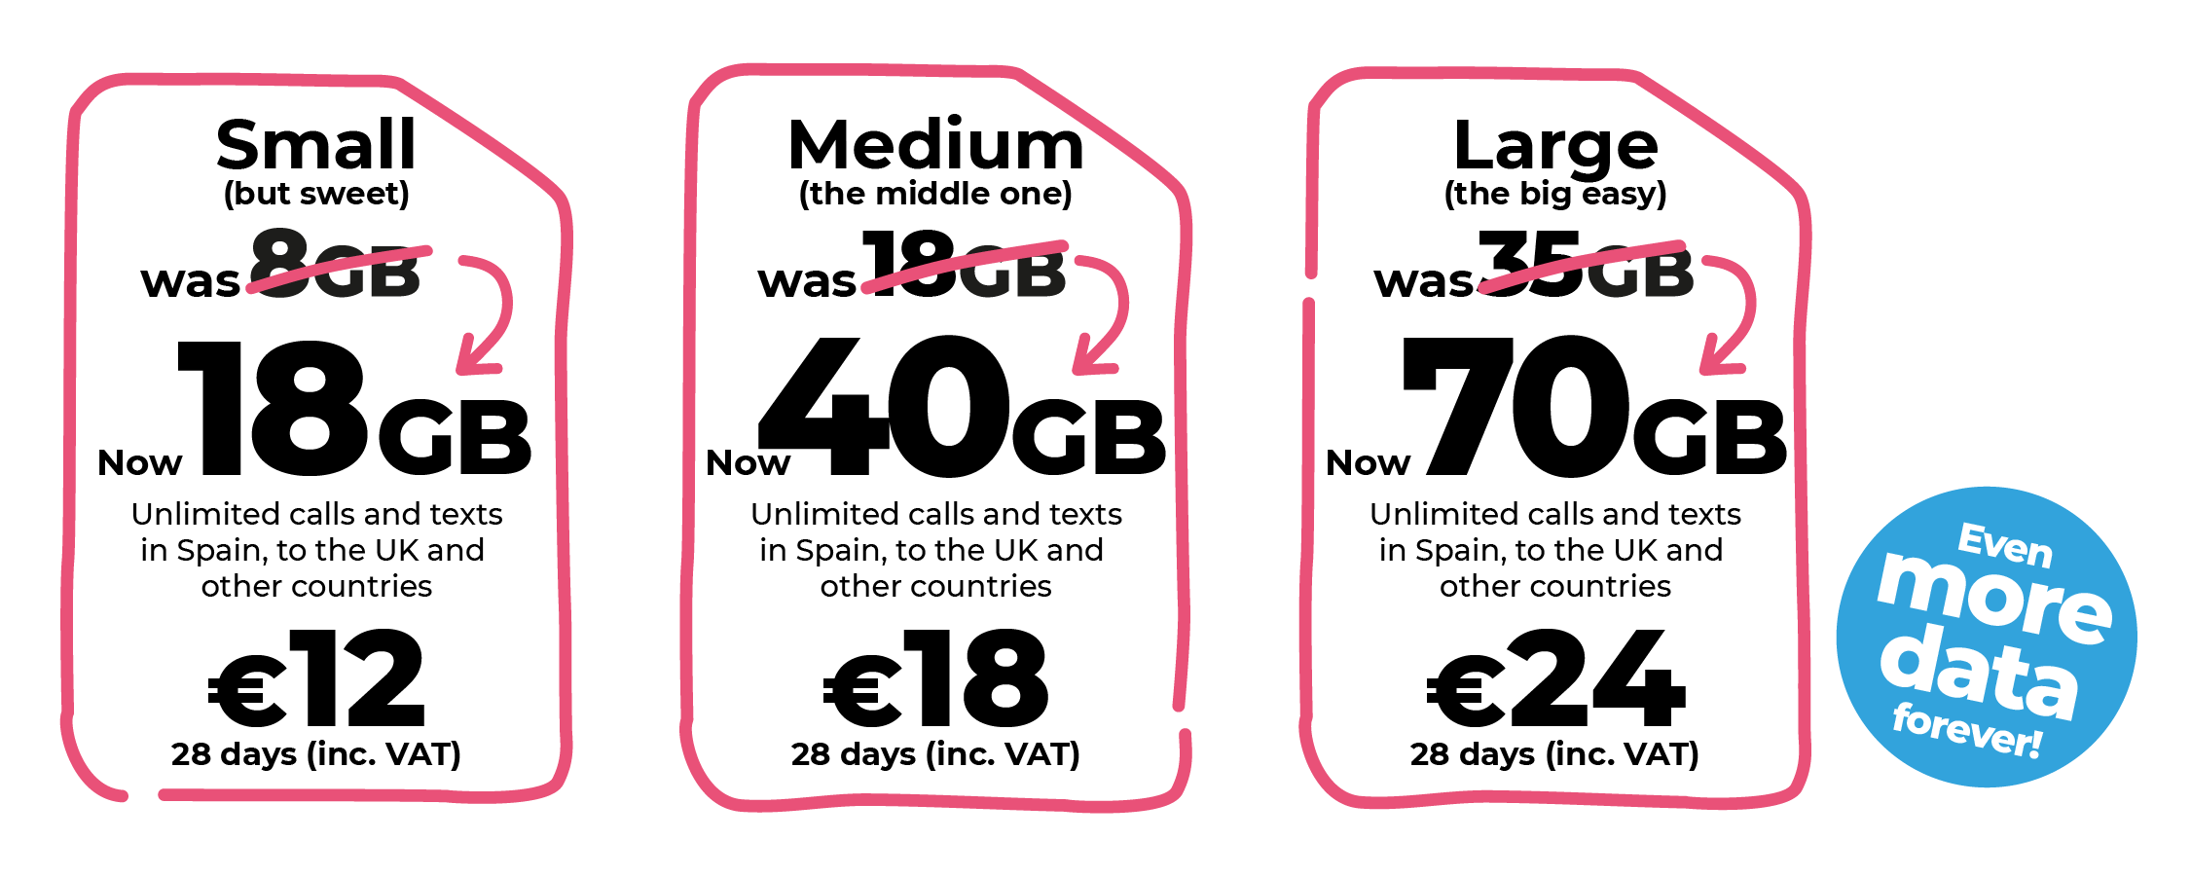
Everyone gets the increase in data, all new customers and current customers. Lobster does not treat new customers better than current ones! All current Lobster customers will get the data increase automatically, without having to do anything.

In addition to unlimited calls and texts in Spain and to the UK, all our tariff plans also include unlimited calls and texts to Denmark, Germany, Gibraltar, Ireland, Netherlands, Norway, Portugal, Sweden and the USA.
With Lobster you can also roam in the UK, or any country in the European Economic Area, at no additional cost.
With Lobster there are no commitments, lock-ins or hidden surprises. Lobster wants its customers to stay because they're happy with the service.
Customers can keep their existing Spanish number if they already have one or we can give them a brand new one.
"We have seen a tremendous demand for more data with our customers surfing and watching more. At Lobster we always put customer satisfaction first and are very excited to announce that all new and current Lobster customers now get double or more data. All this for the same price, and of course, the same great first-class service as always. There has never been a better time to join Lobster!" said Tony Watts, Marketing Director of the company.
It is very easy to become a Lobster customer, just provide identification, your credit or debit card payment details through a totally secure process, and you’re good to go. It doesn't have to be a Spanish credit or debit card. You can cancel at any time.
Signing up for the service can be done online on our website lobster.es or by calling our Customer Contact Centre for free on 1661 where all the agents are native English speakers. If customers prefer, they can also sign up through any one of over 600 retail stores, the closest of which can easily be found using the store finder on our website lobster.es.

ABOUT LOBSTER
Lobster is the only mobile operator in Spain to offer a service completely in English for British expatriates, and other English speakers, who reside in Spain. Lobster is the registered brand of Zinnia Telecomunicaciones, a Spanish company and part of the Gibtelecom Group. Zinnia Telecomunicaciones has the financial and business support of Gibtelecom, the main operator in Gibraltar providing fixed lines, mobile and TV, as well as business enterprise services. The Group has submarine cable and European fibre network investments, and runs data centres through its subsidiary, Rockolo Limited.
Press Contact
Telephone 711 000 125, Email press@lobster.es
More information at lobster.es or find us on Twitter, Facebook, Instagram or YouTube.

